24. The United Kingdom of Great Britain and Northern Ireland

/Spojené Kráľovstvo Veľkej Británie a Severného Írska/

Talk about – rozprávajte o:
- General information – všeobecné informácie
  - location + population – poloha + obyvateľstvo
  - industry& agriculture – priemysel & poľnohospodárstvo
  - educational system – systém vzdelávania
- Interesting places in Britain – zaujímavé miesta v Británii
- London – the capital city – Londýn – hlavné mesto
- Famous people in Britain – slávni ľudia v Británii
- Customs & traditions – zvyky a tradície

1. General information
The UK is a country, which is situated on two main islands /ostrovy/:
- Great Britain
- Ireland

Great Britain consists of these countries:
- England – the capital city = London
- Scotland – the capital city = Edinburgh
- Wales – the capital city = Cardiff
- Northern Ireland – the capital city = Belfast

Its area is 244 872 km² /square kilometers/ and the population is about 59 mil. inhabitants. The capital city is London and the currency is 1 GBP /1 British pound/. The United Kingdom is a constitutional monarchy and the head of the state is the Queen Elizabeth II. The head of the government is the Prime minister – it is Gordon Brown now.
The country has a mild and rainy climate. The most important river is the Thames /Temža/ and the longest river is the Severn.

INDUSTRY /priemysel/ & AGRICULTURE /poľnohospodárstvo/:
The UK is a very industrialized country. Services /služby/ - for example finance, banking, computing, advertising and so on, are now a very important part of the British industry. Other important industries are also iron /železiarsky/ and steel /oceliarsky/ industry, textil, plastics and food industry.
The main agricultural products are potatoes, sugar beet /cukrová trstina/, milk, meat, wheat /pšenica/ and so on.

THE BRITISH SYSTEM OF EDUCATION:
The compulsory school attendance in Britain starts at the age of 5.
Children start primary education – it is divided into infant schools and junior schools. Pupils at most of the primary and secondary schools have to wear uniforms, which are usually different for every school.
At the age of 11, most children start secondary education - it is compulsory until the age of 16, when the students take an exam called “GCSE” (General Certificate of Secondary Education). Students, who pass the GCSE exam can attend a 2-years long course and take A-levels examination. They can go to university only if they pass A-levels.

2. Interesting places in Britain
England:
- Stonehenge – it is a historical place made of big stones in the south of England. Scientists are still trying to discover, why it was built. Some of them think that it was a religious place for burials /náboženské miesto na pohreby/, others think that it was used as a calendar. Scientists still don’t know how it was built.

Stonehenge Nessie – the Loch Ness monster
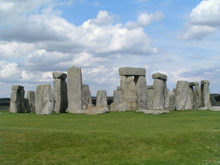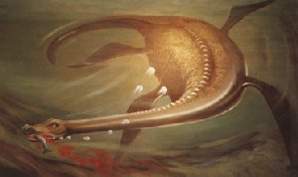

- Liverpool – is the home of the famous band called the Beatles.
- Oxford, Cambridge – these are the famous university towns
- Stratford upon Avon – it is the birthplace of William Shakespeare – he was a famous English writer and dramatist – he wrote Romeo and Juliet, Mackbeth, Hamlet and so on.
- London – the capital city of England
Scotland:
- Lake Loch Ness – lakes are in Scotland called “Loch” – one of the biggest lakes is the lake Loch Ness. People believe that a monster called Nessie lives in this lake. Many people say they have seen this monster – scientists are trying to find out if it really exists. They think it could be an animal that lived in pre-historic times and it survived in the lake because it had good conditions for life there.
- Glasgow – it is the biggest city in Scotland – it is an important economic and tourist centre of Scotland

LONDON
London is the capital city of England and one of the world’s largest cities /it covers the area of 1579 km²/. It is situated in the south of England and it has the population of about 7,5 million people. London is a very multicultural city – people of different origins, races and religions live there. London is crossed by the river Thames. London is today one of the world's leading business, financial and cultural centres. There are 5 airports and a large port in London – the most important airport is called Heathrow.
London’s history:
London was first settled in about 43 AD by the Romans => this settlement was called Londinium – today’s name “London” comes from this old name. In the past many different nations tried to conquer London – it was attacked by Celts, Anglo-Saxons, the Spanish and so on. In the 17th century there was a large fire /known as “The Great Fire of London”/, which destroyed many parts of London. In the 19th century it became the largest city and the first railways were built.

These are the London’s most important sightseeing places /pamiatkové miesta/:

- The Houses of Parliament /also called The Westminster Palace/ - Budovy Parlamentu – they stand on the bank of the river Thames. They are buildings in Gothic style => the Houses of parliament consist of 2 houses:
  - The House of Lords – Snemovňa Lordov
  - The House of Commons
- Big Ben – it is the clock tower which belongs to the Houses of Parliament => the clock has the name of Sir Benjamin Hall – he was very tall and so his friends called him Big Ben. The clock has 7 meters in diameter and it weighs 13 tons. It is the biggest bell in England.
- The London Eye /Londýnske Oko/– the world’s largest observation wheel and the London’s most popular tourist attraction
- The Tower Bridge – a bridge which is near the Tower of London. It is low over the river and it must be opened for the big ships => signals for ships and cars are sent by traffic lights.
- The Tower of London – it is near the Tower Bridge. It was a prison /väzenie/, a fortress /pevnosť/, a palace in the past => visitors can see the crown jewels /korunovačné klenoty/ there.
- Buckingham Palace – it is the residence of the Queen. She lives here with her family. The first queen who lived in Buckingham Palace was the Queen Victoria. In summer tourists can visit the Buckingham Palace because it is opened to public and they can also see the changing of the guard.
- St. Paul’s Cathedral /Katedrála Sv. Pavla/
- Madame Tussaud’s Wax Museum /Múzeum voskových figurín Madam Tussaudovej/ – there are figurines of famous people made of wax /z vosku/.

STREETS /ulice/ AND SQUARES /námestia/:
- Trafalgar Square /Trafalgarské Námestie/ - it is famous for its pigeons /holuby/. Every year, people from London celebrate the New Year there. The square is on the place where French were defeated by English under Admiral Lord Nelson => there is Nelson’s column /Nelsonov pamätník/.
- Piccadilly Circus – it is the biggest and oldest square in London => it is the heart of London’s entertainment world – there are many shops, restaurants, small theatres and night clubs. In the middle of Piccadilly there is a statue of EROS – the god of Love.
- Oxford Street – the biggest shopping street in London. There are many shopping centres and also many small shops.

PARKS IN LONDON:
- Hyde Park – the biggest park in London. In the Hyde Park there is a place called the Speaker’s corner /Rečnícky kútik/ where people can say their opinions on public, religious and political issues.
- St. James’ Park – it is oldest of the Royal Parks in the city of Westminster – it is east of the Buckingham Palace.
- Kensington Gardens - it is now a park, but in the past it was a private garden, which belonged to the Kensington Palace => we can see there the Albert Memorial, Peter Pan Statue and other buildings and monuments.
- Greenwich Park

The London Eye The Houses of Parliament
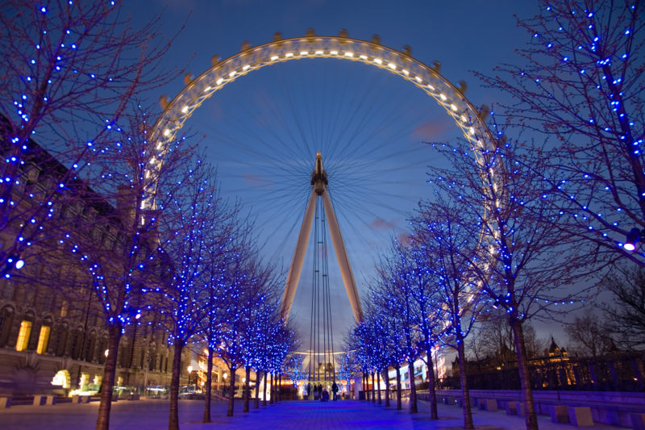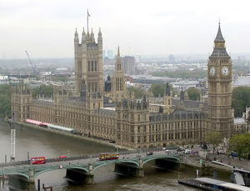

The Tower Bridge The Tower of London
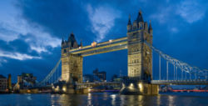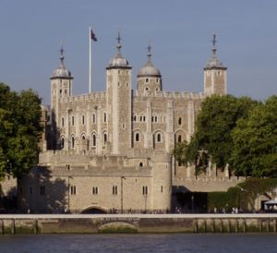

4. Famous people in Britain
- The Royal Family /Kráľovská rodina/ - it consists of the Queen Elizabeth II., her husband and their children => Prince Charles, Princess Anne, Prince Andrew and Prince Edward. Prince Charles was married to Princess Diana who died in a car crash in 1997. They had 2 sons – William and Harry. At present Prince Charles is married to Camilla Parker Bowles. The Royal family lives in the Buckingham palace which is the residence of the Queen.
- The Prime Minister – the Prime Minister lives and has his office in 10 Downing Street in London. The British Prime Minister is now Gordon Brown.
- Pop singers – the Beatles, Robbie Williams… - the Beatles come from Liverpool and their songs are very popular and still played on the radios. They consisted of 4 members /John Lennon, Paul McCartney, George Harrison, Ringo Star/ => they were very popular in the 60’s. John Lennon was killed by a fan.

5. Customs and traditions
British people are considered conservative. People celebrate these holidays:
- Easter holiday – in England children often boil chicken’s eggs and paint them with bright colours. Then they all get together on top of a hill and have an egg race => they roll the eggs down the hill
- Mother’s Day – 2nd Sunday in May => children give flowers and presents to their mothers
- The Queen’s Official Birthday – Saturday after the 9th of June – a ceremonial meeting of the guard in the presence of the Queen.
- Halloween – the 31st of October – children dress up in Halloween costumes with masks on their faces. They carry baskets and they go to their friend’s and neighbour’s houses and they knock at the door. People give them sweets, fruit or money.
- Bonfire Night /Guy Fawkes’ Night/ - Noc Ohňostrojov - the 5th of November – people remember the day in 1605 when a group of people tried to blow up the House of Lords with gunpowder => they were all executed and Guy Fawkes is the most famous of the conspirators.
- Christmas – people in Britain have the Christmas dinner on the 25th of December. In the morning, when the children wake up, they find presents under the Christmas tree. In the evening the family has Christmas dinner together – they have a turkey and the Christmas pudding.

Vocabulary:

main – hlavný
consist of – pozostávať z
inhabitants – obyvatelia
currency – mena
British pound /GBP/ - Britská libra
a constitutional monarchy – konštitučná monarchia
government – vláda
the Prime minister – premier
mild and rainy climate – mierne a daždivé podnebie
important – dôležitý
advertising – reklama
compulsory school attendance – povinná školská dochádzka
primary education – základné vzdelanie
divide – rozdeliť
pupils – žiaci
have to – musieť
different – odlišný
an exam – skúška
call – volať, nazývať sa
pass an exam – spraviť skúšku
attend a course – navštevovať kurz
stone – kameň, skala
scientists – vedci
discover – objaviť, zistiť
build /min. čas built-built/ - postaviť
others think – ďalší, iní si myslia
it was used as a calendar – bolo používané ako kalendár
band – skupina
the birthplace – rodisko
lake – jazero
believe – veriž
a monster – príšera
people say they have seen this monster – ľudia hovoria, že videli túto príšeru
it could be – mohlo by to byť
survive – prežiť
good conditions for life – dobré podmienky pre život
important – dôležitý
cover – pokrývať, zaberať /priestor/
a multicultural city – multikultúrne mesto
origin – pôvod
religion – náboženstvo
race – rasa
London is crossed by the river Thames. – Londýnom preteká rieka Temža.
leading – vedúce
airport – letisko
a large port – veľký prístav
London was first settled in about 43 AD by the Romans. – Londýn bol najskôr osídlený okolo roku 43 nášho letopočtu Rimanmi.
settlement – osídlenie
in the past – v minulosti
nation – národnosť
try to /min. čas tried – tried/ - pokúsiť sa, skúsiť
to conquer – dobyť
It was attacked by Celts. – Bol napadnutý Keltmi.
a large fire /known as “The Great Fire of London”/ - veľký oheň /známy ako “Veľký Londýnsky Oheň”/
destroy – zničiť
part – časť
century – storočie
become – stať sa
railway – železnica
sightseeing places – miesta, kam si chodíme pozerať pamiatky
on the bank of the river – na brehu rieky
buildings in Gothic style – budovy v gotickom štýle
the clock tower – veža s hodinami
tall – vysoký
7 meters in diameter – 7 m v priemere
weigh – vážiť
bell – zvon
observation – pozorovanie
wheel – koleso
a bridge – most
near – blízko
tower – veža
low over the river – nízko nad riekou
signals for ships and cars are sent by traffic lights – signály pre lode a autá sú vysielané semaformi
visitors – návštevníci
queen – kráľovná
it is opened to public – je otvorený pre verejnosť
the changing of the guard – zmena stráže
celebrate – oslavovať
French were defeated by English under Admiral Lord Nelson. – Francúzi boli porazení Angličanmi pod vedením Admirála Lorda Nelsona.
entertainment – zábava
in the middle – v strede
a statue – socha
People say their opinions on public, religious and political issues. – Ľudia hovoria svoje názory na verejné, náboženské a politické problémy.
the Royal Parks – Kráľovské parky
married to – zosobášený s
a car crash – dopravná nehoda
at present – v súčasnosti
office – kancelária
The Beatles’ songs still played on the radios. – Piesne od Beatles sú ešte stale hrávané v rádiách.
member – člen
a fan - fanúšik
consider – považovaný
conservative – konzervatívny /nemá rád zmeny/
boil chicken’s eggs – uvariť kuracie vajíčka
paint them with bright colours – nafarbiť ich jasnými farbami
get together – stretnúť sa
on top of a hill – na vrchu kopca
race – súťaž, preteky
roll the eggs down the hill – kotúľať vajíčka dole kopcom
the Qeen’s Official Birthday – Kráľovnine oficiálne narodeniny
the guard – stráž
presence – prítomnosť
dress up – vyobliekať sa
carry baskets – niesť košíky
neighbour – sused
knock at the door – zaklopať na dvere
sweets – sladkosti
bonfire – ohňostroj
remember – pripomínať si, spomínať si
blow up – vyhodiť do povetria
gunpowder – pušný prach
execute – popraviť
conspirator – sprisahanec
a turkey - moriak
the Christmas pudding – vianočný puding

